**Basics of A.W.S. / G.C.P. Services**

**1435 - Jainil Sanghavi**

1. **What are cloud services & why to use them?**

* The term “Cloud Services” refers to a wide range of services delivered on demand to companies and customers over the Internet. These services are designed to provide easy, affordable access to applications and resources, without the need for internal infrastructure or hardware.

There are 3 types of services:

1. **Infrastructure as a Service (IaaS):** IaaS is also known as **Hardware as a Service (HaaS)**. It is a computing infrastructure managed over the internet. The main advantage of using IaaS is that it helps users to avoid the cost and complexity of purchasing and managing the physical servers.

Example: DigitalOcean, Linode, Amazon Web Services (AWS), Microsoft Azure, Google Compute Engine (GCE), Rackspace, and Cisco Metacloud.

1. **Platform as a Service (PaaS):** PaaS cloud computing platform is created for the programmer to develop, test, run, and manage the applications.

Example: AWS Elastic Beanstalk, Windows Azure, Heroku, Force.com, Google App Engine, Apache Stratos, Magento Commerce Cloud, and OpenShift.

1. **Software as a Service (SaaS):** SaaS is also known as "**On-Demand Software**". It is a software in which the applications are hosted by a cloud service provider. Users can access these applications with the help of internet connection and web browser.

Example: BigCommerce, Google Apps, Salesforce, Dropbox, ZenDesk, Cisco WebEx, ZenDesk, Slack, and GoToMeeting.

**Advantages of using Cloud Services:**

* Back-up and Restore Data
* Improved Collaboration
* Excellent Accessibility
* Low Maintenance Cost
* Mobility
* Unlimited Storage Capacity
* Data Security

**2) Create an account on AWS and GCP. Get familiar with UI.**

**3) Learn below AWS Services.**

1. **EC2:** AmazonEC2 stands for Amazon **Elastic Compute Cloud**. Amazon EC2 is a web service that provides resizable compute capacity in the cloud.

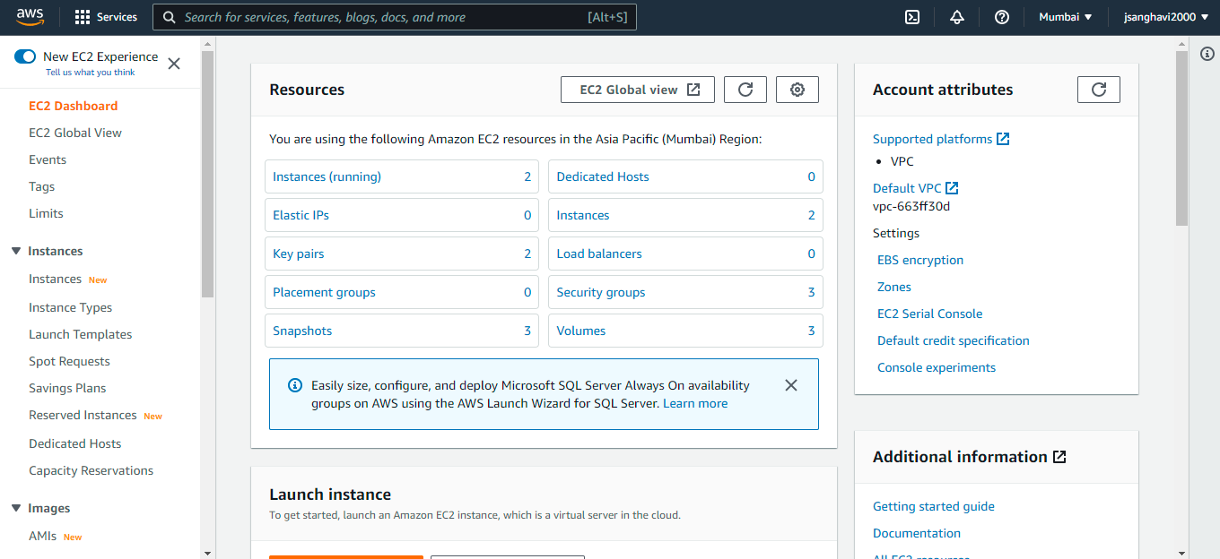

**Creating an EC2 Instance:**

1. Choose AMI
2. Choose Instance Type
3. Configure Instance
4. Add Storage
5. Add Tags
6. Configure Security Groups
7. Review

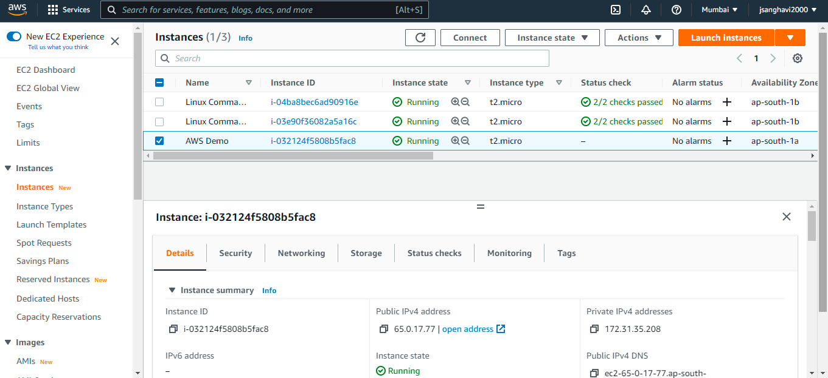

**Connecting my ec2 instance to PuTTy.**

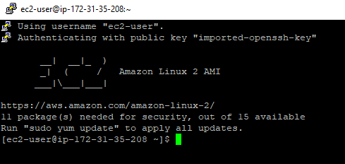

1. **EIP: Elastic IP address** is a service provided by an EC2 instance. It is basically a static IP address attached to an EC2 instance. This address is associated with your AWS account not with an EC2 instance. You can also disassociate your EIP address from your EC2 instance and map it to another EC2 instance in your AWS account.

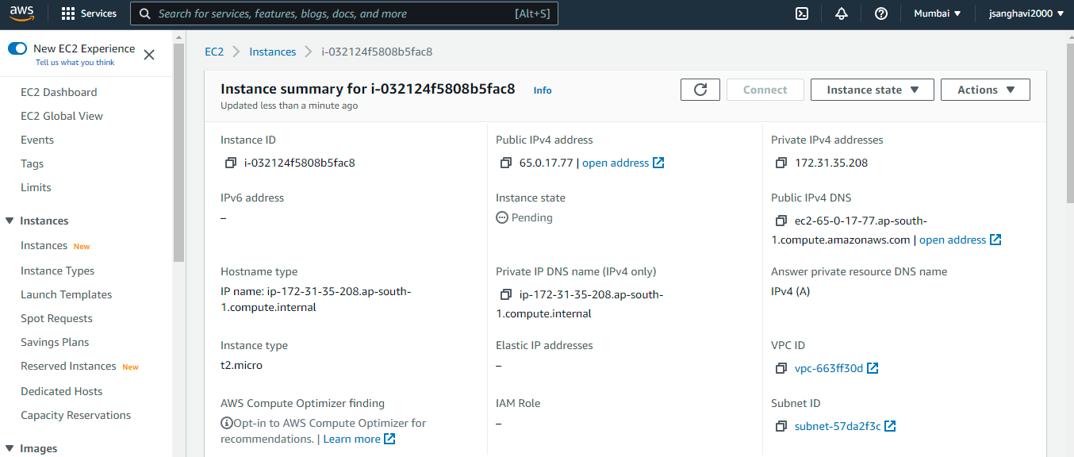

1. **SG:** A **Security Group** is a virtual firewall which is controlling the traffic to your EC2 instances. When you first launch an EC2 instance, you can associate it with one or more security groups. A Security group is the first defence against hackers.

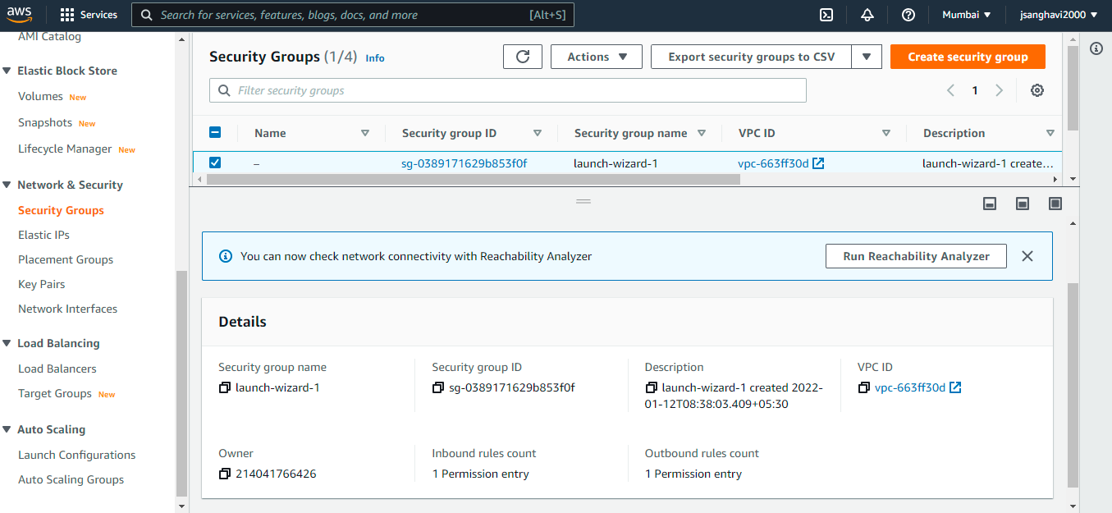

**Inbound Rules for Security Groups:**

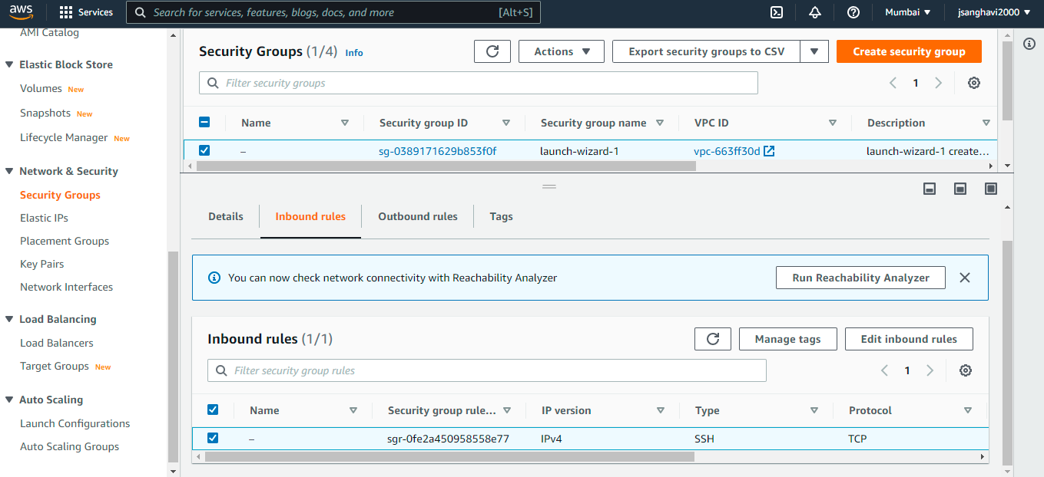

**Outbound Rules for Security Groups:**

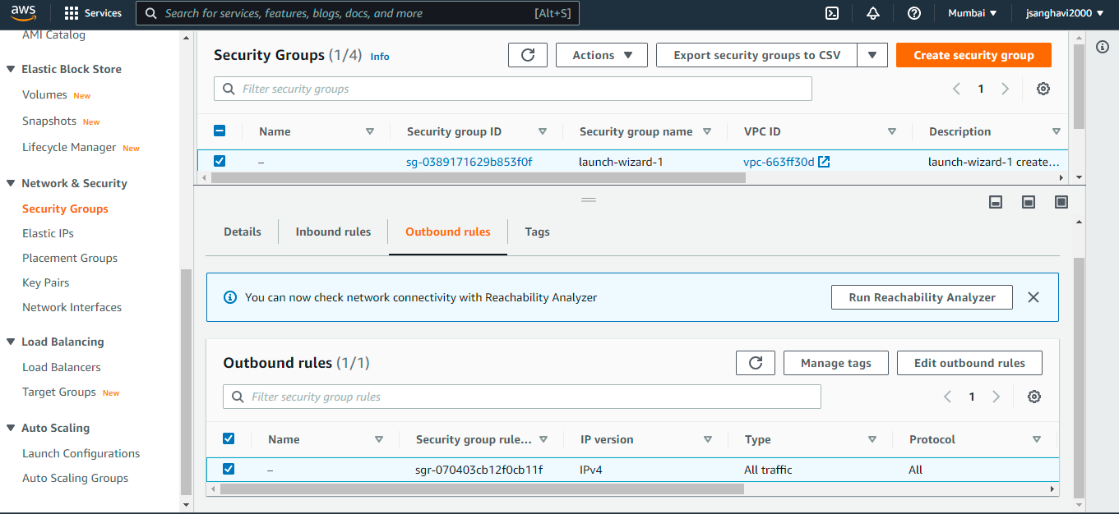

1. **Ephemeral Volume:** Instance store volumes also known as virtual devices have underlying hardware physically attached to the host computer for the instance. Instance store volumes support ephemeral [0-23]. Whenever you launch an EC2 instance, the instance store volume type is ephemeral by default.

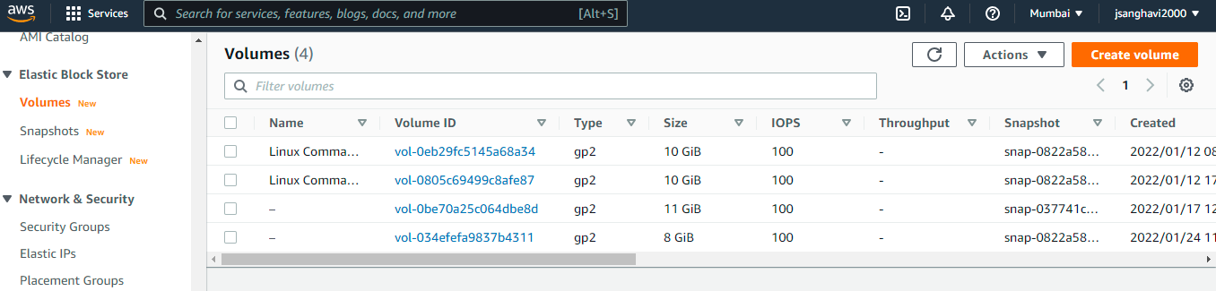

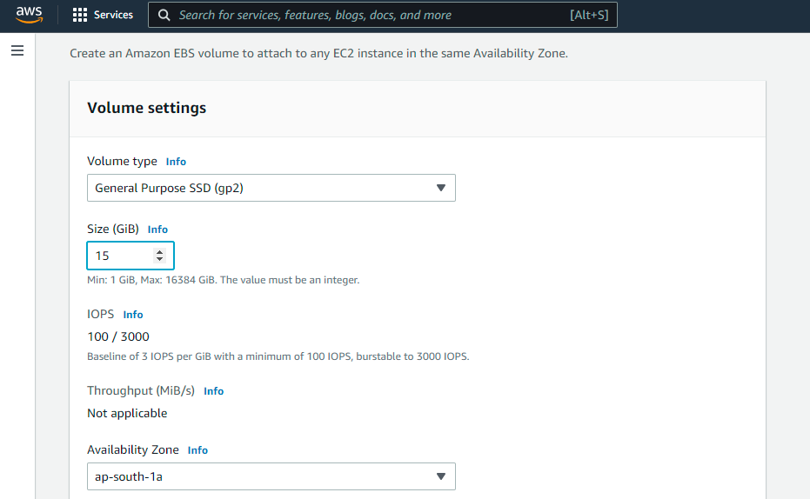

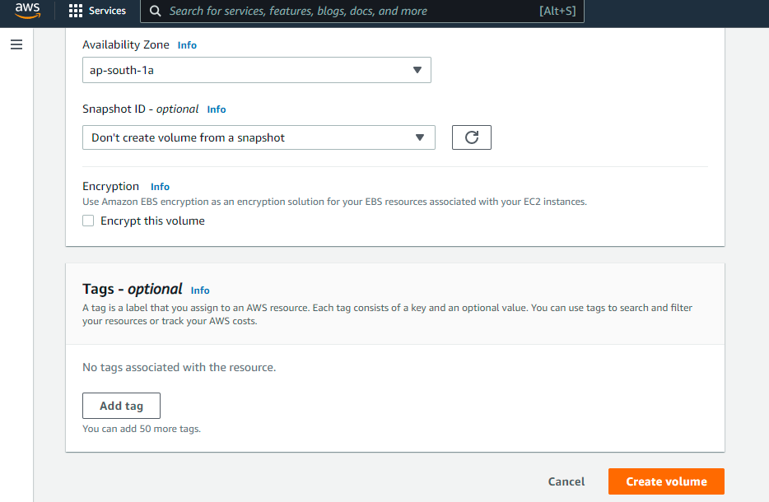

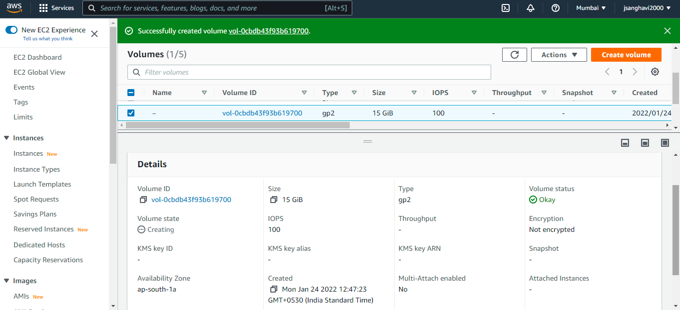

1. **EBS and Snapshot:** EBS stands for **Elastic Block Store**. EC2 is a virtual server in a cloud while EBS is a virtual disk in a cloud. Amazon EBS allows you to create storage volumes and attach them to the EC2 instances.

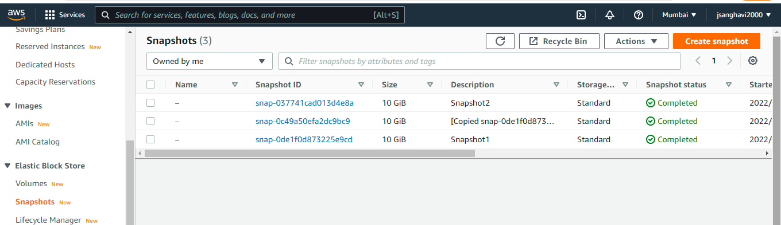

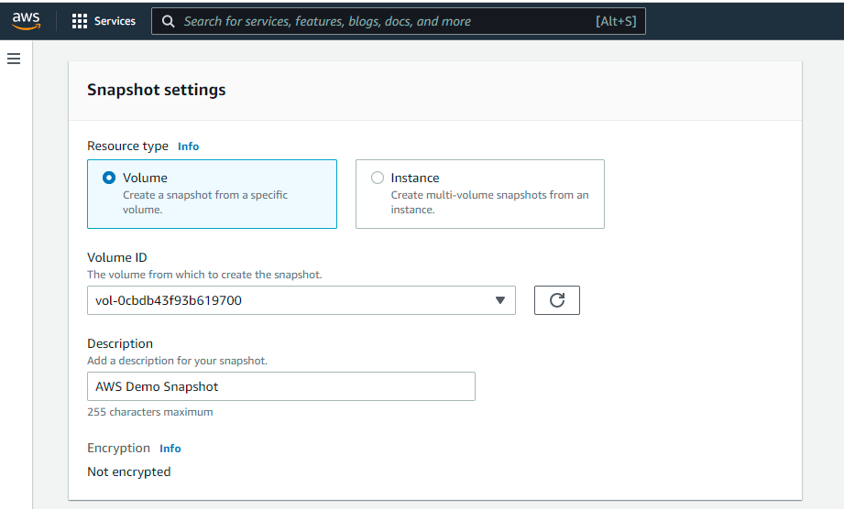

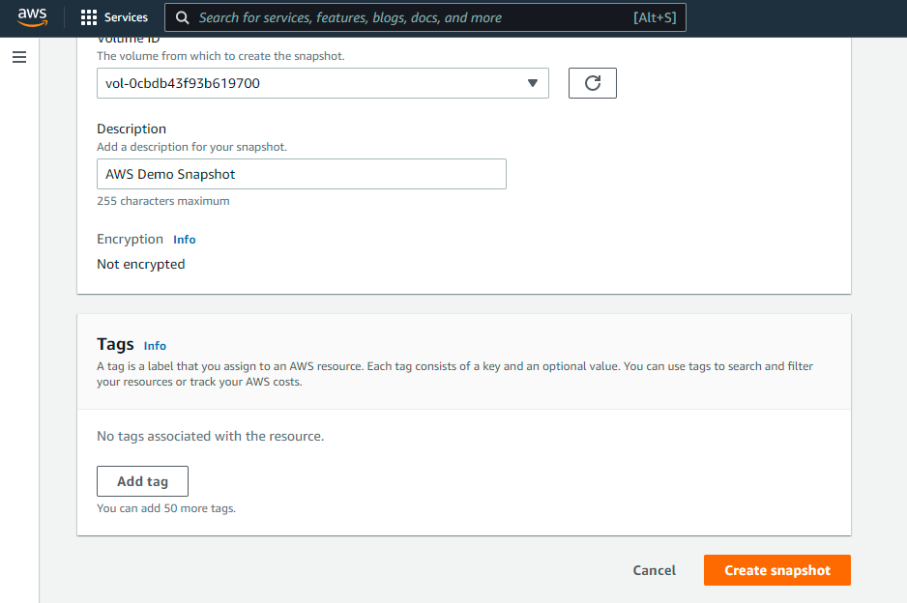

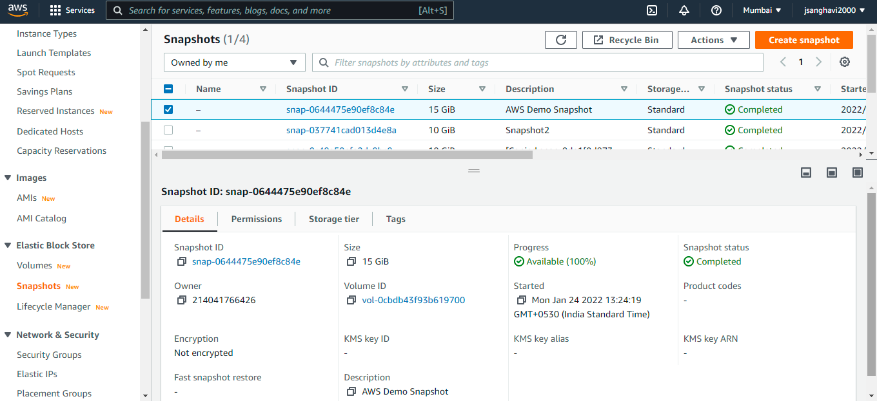

1. **ELB: Elastic Load Balancer** is a virtual machine or appliance that balances your web application load that could be Http or Https traffic that you are getting in. It balances a load of multiple web servers so that no web server gets overwhelmed.

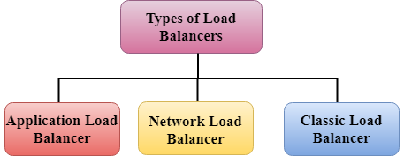

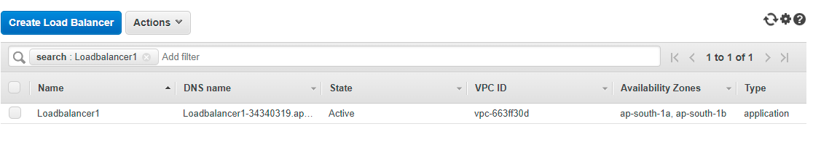

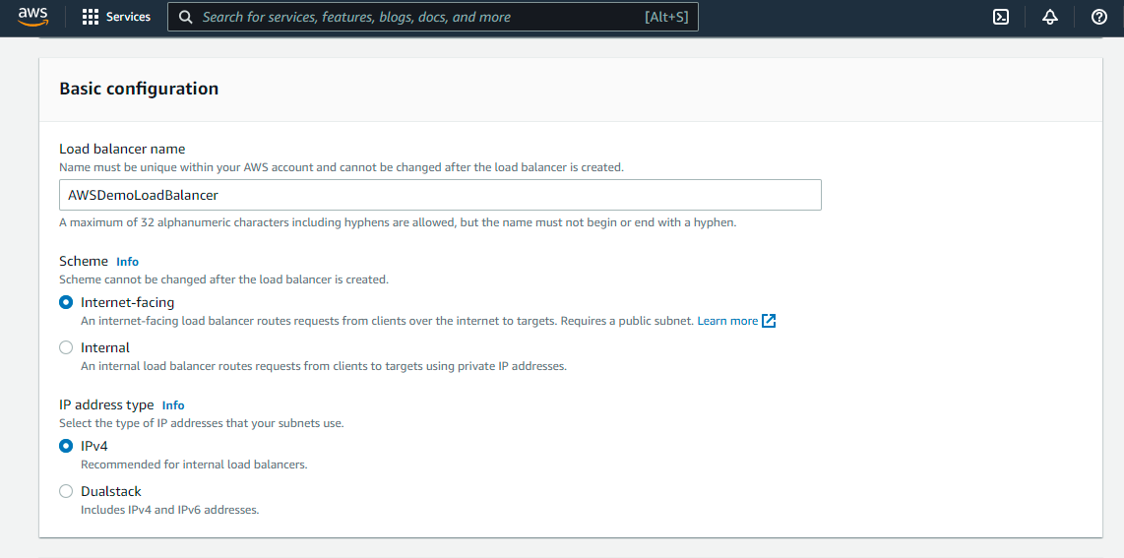

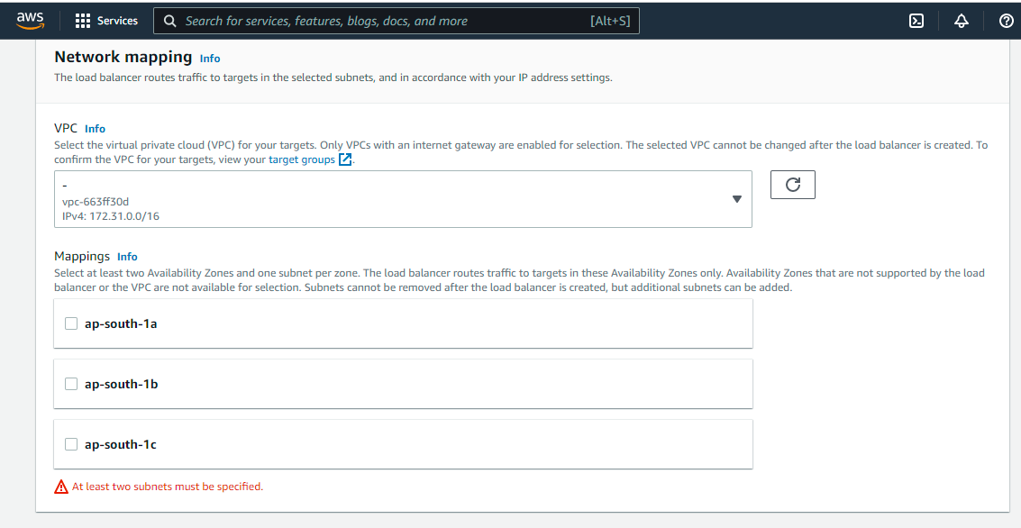

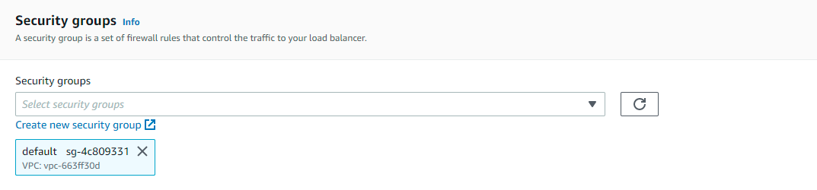

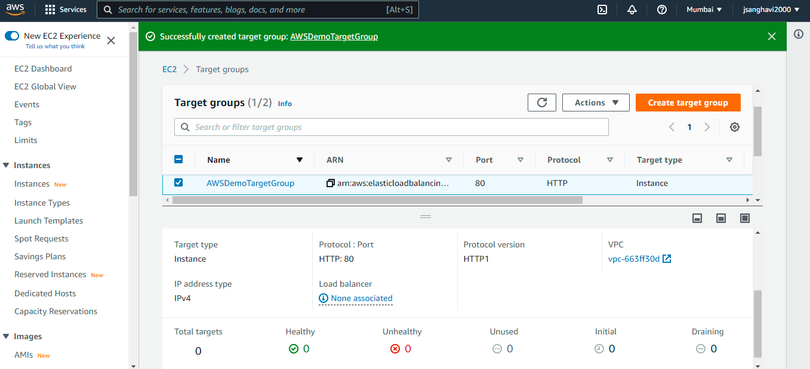

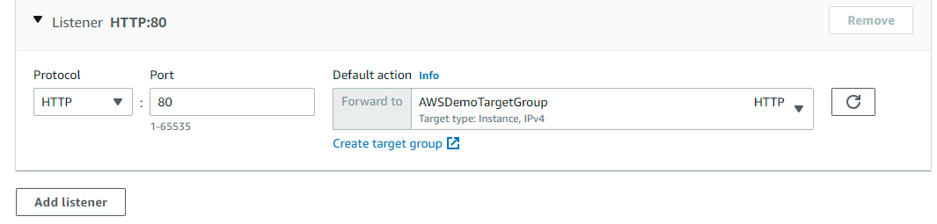

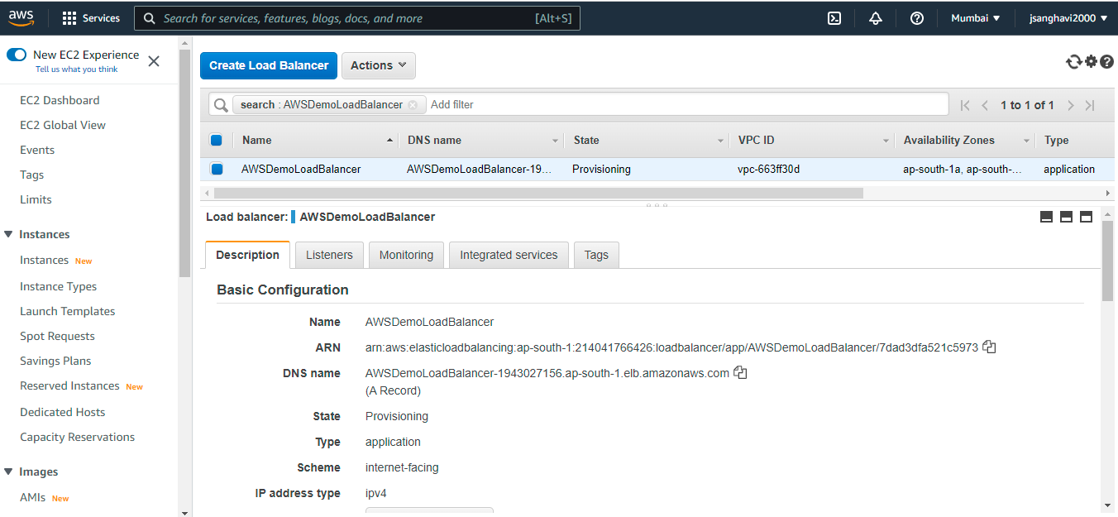

1. **ASG: Auto Scaling** is a feature in aws that automatically scales the capacity to maintain steady and predictable performance. While using auto scaling, you can scale multiple resources across multiple services in minutes.

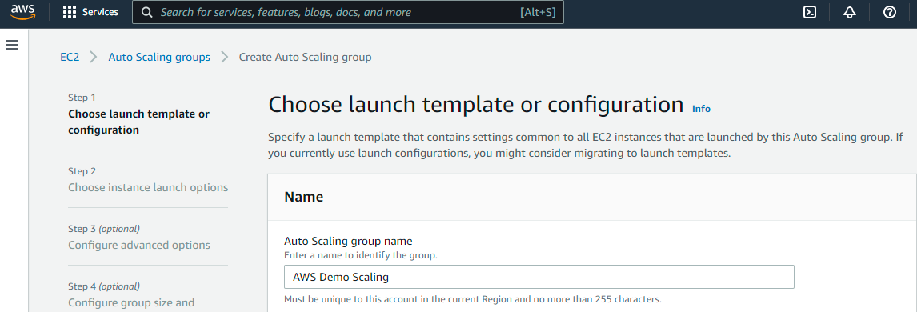

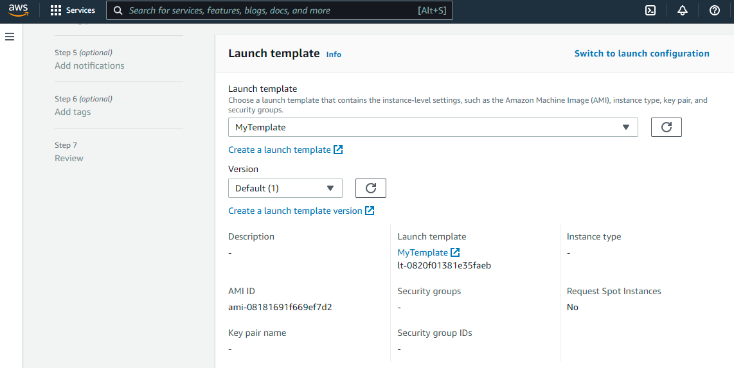

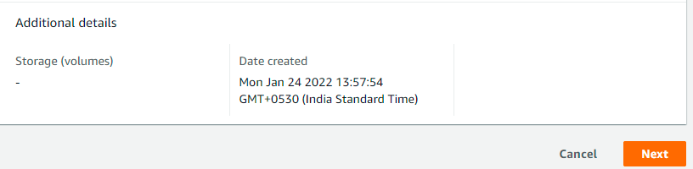

1. **AMI:** An AMI stands for **Amazon Machine Images**. An AMI is a virtual image used to create a virtual machine within an EC2 instance.

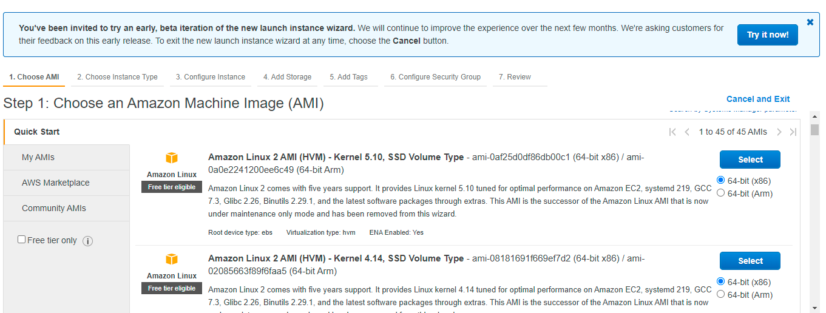

1. **VPC:** VPC stands for **Virtual Private Cloud**. Amazon Virtual Private Cloud (Amazon VPC) provides a logically isolated area of the AWS cloud where you can launch AWS resources in a virtual network that you define.

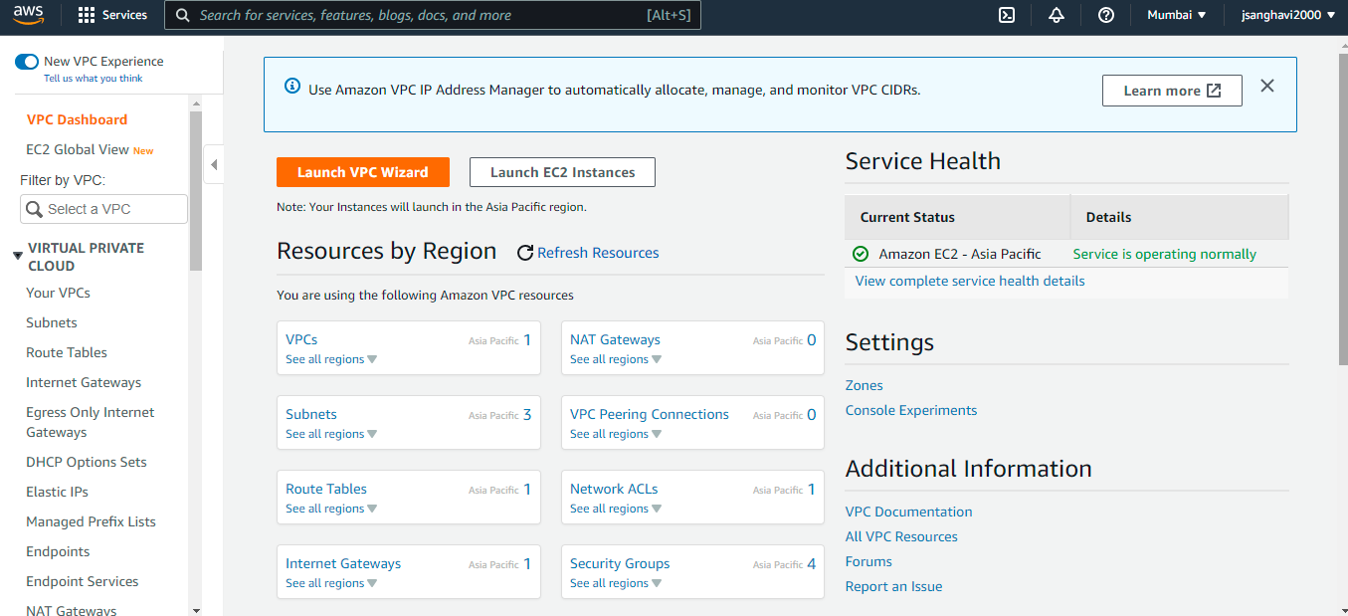

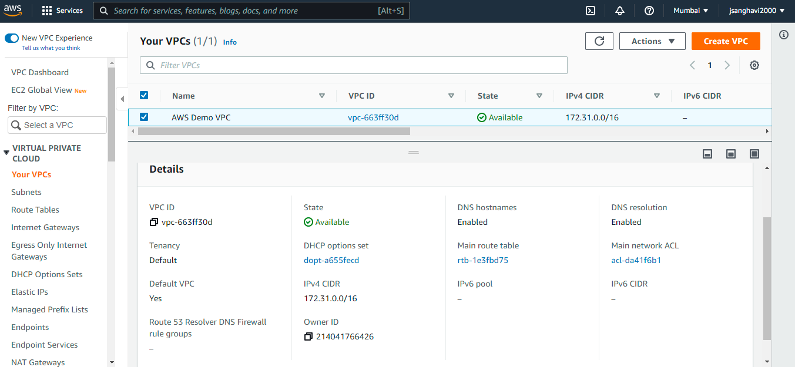

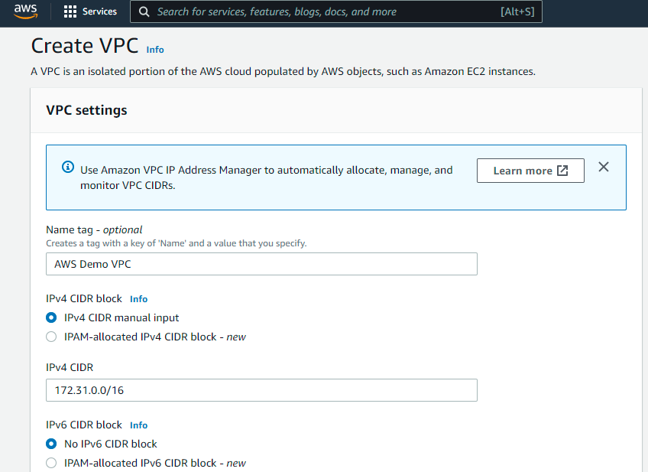

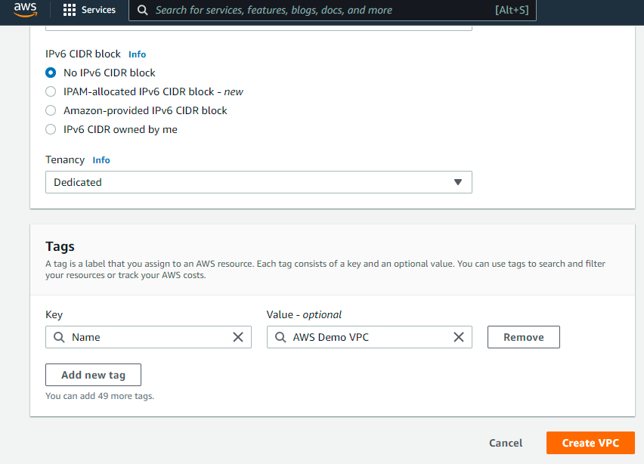

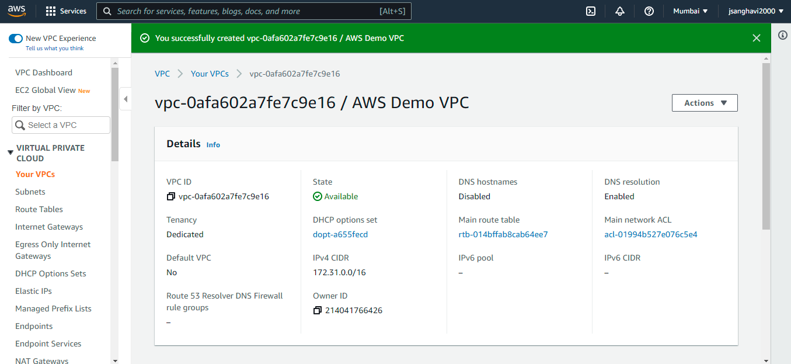

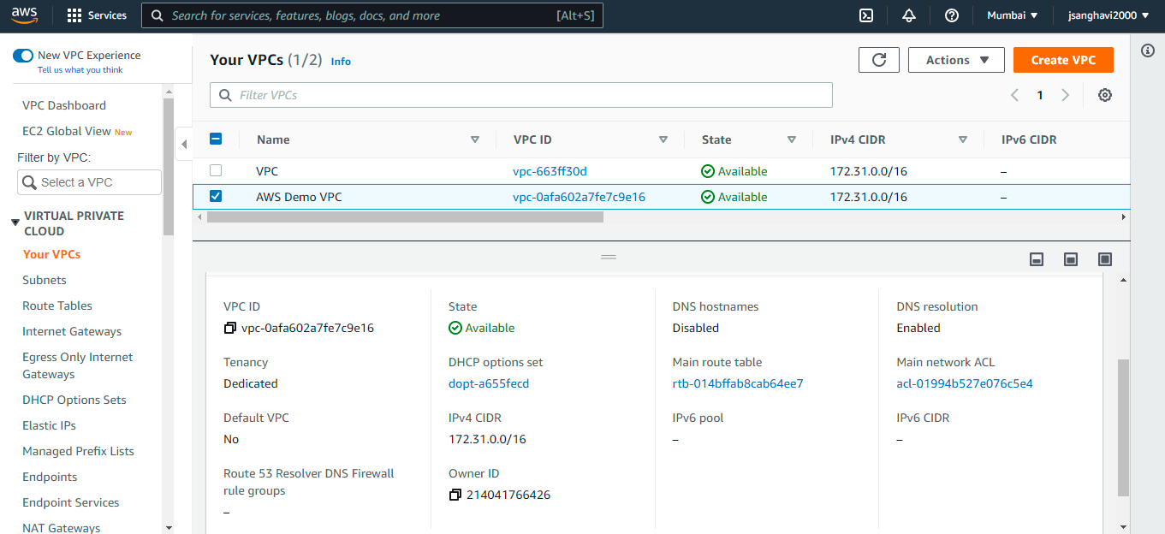

1. **IAM:** IAM stands for **Identity Access Management**. IAM allows you to manage users and their level of access to the aws console. It is used to set users, permissions and roles. It allows you to grant access to the different parts of the aws platform. AWS Identity and Access Management is a web service that enables Amazon Web Services (AWS) customers to manage users and user permissions in AWS.

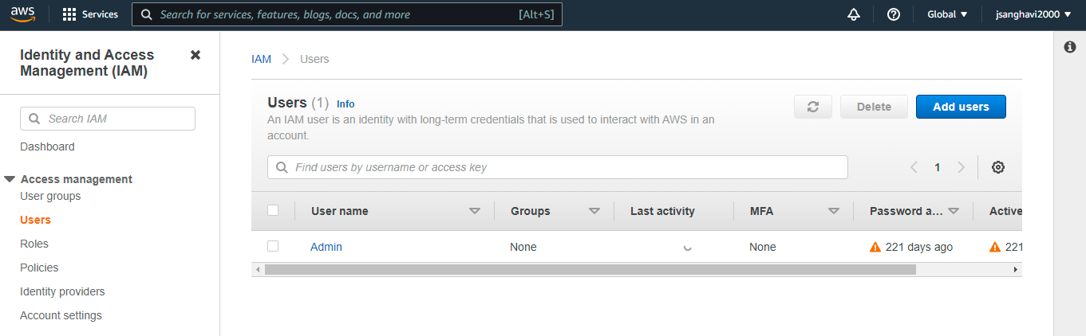

1. **S3:** S3 stands for **Simple Storage Service**. S3 provides developers and IT teams with secure, durable, highly scalable object storage. It is easy to use with a simple web services interface to store and retrieve any amount of data from anywhere on the web. S3 is a safe place to store the files. It is Object-based storage, i.e., you can store the images, word files, pdf files, etc. The files which are stored in S3 can be from 0 Bytes to 5 TB. It has unlimited storage which means that you can store the data as much as you want. Files are stored in Bucket. A bucket is like a folder available in S3 that stores the files.

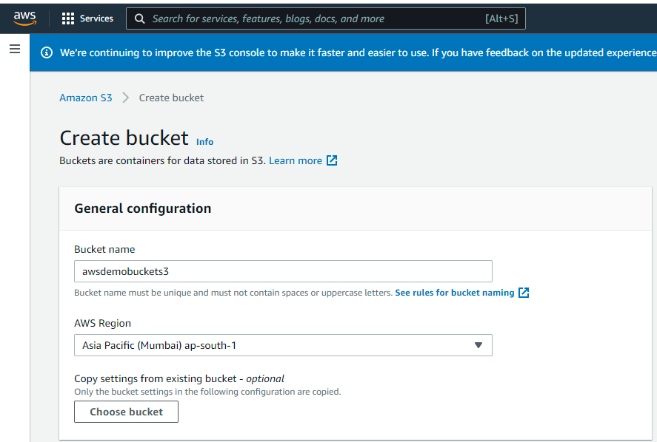

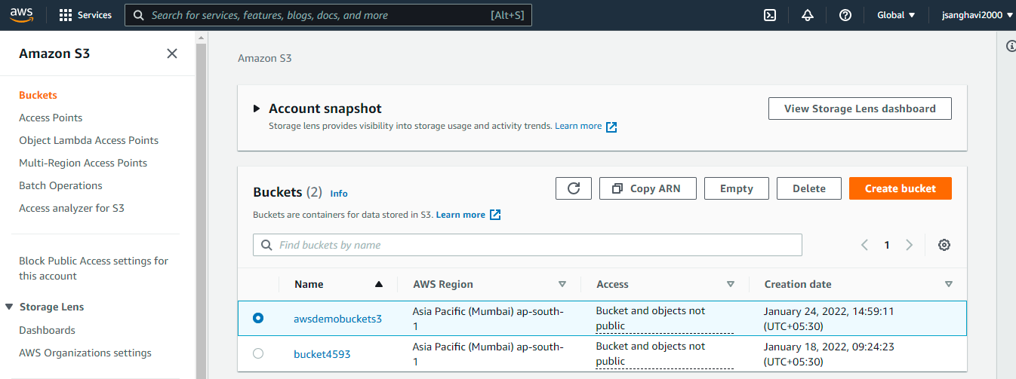

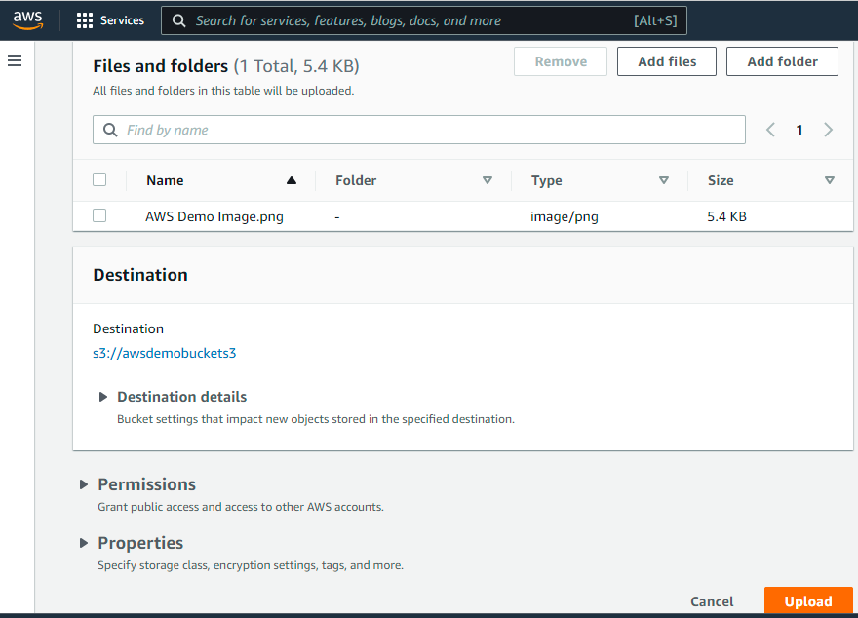

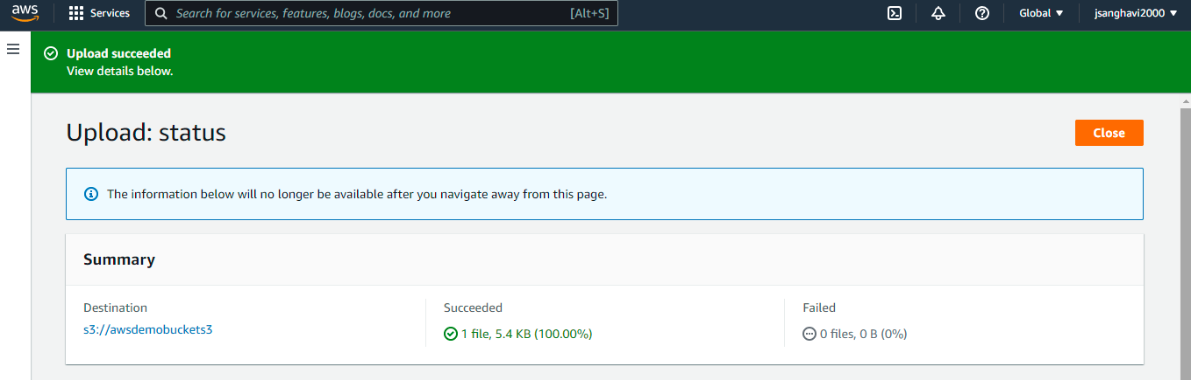

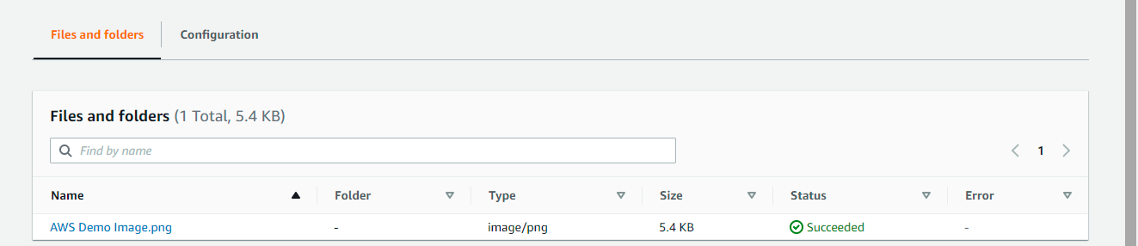

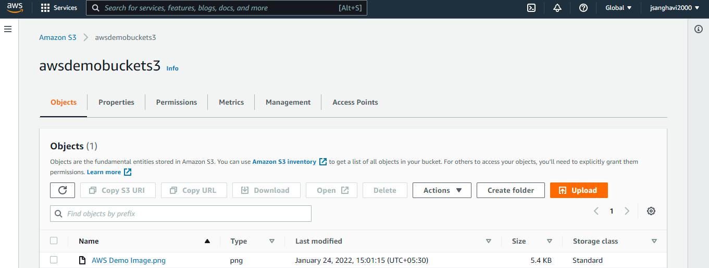

1. **Cloudwatch: CloudWatch** is a service used to monitor your AWS resources and applications that you run on AWS in real time. CloudWatch is used to collect and track metrics that measure your resources and applications. It displays the metrics automatically about every AWS service that you choose.

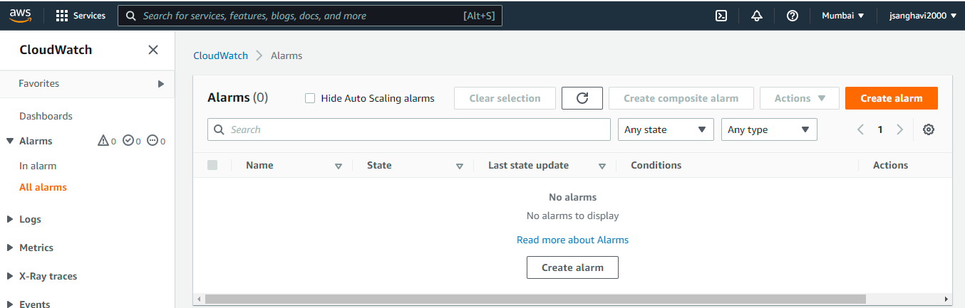

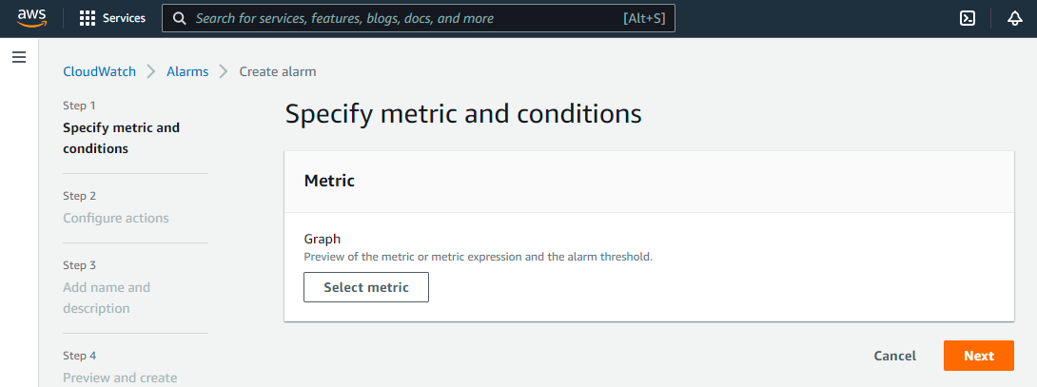

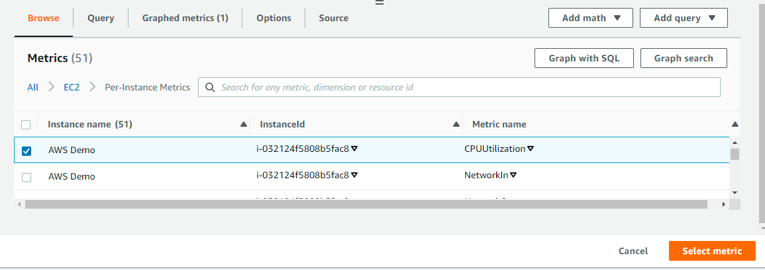

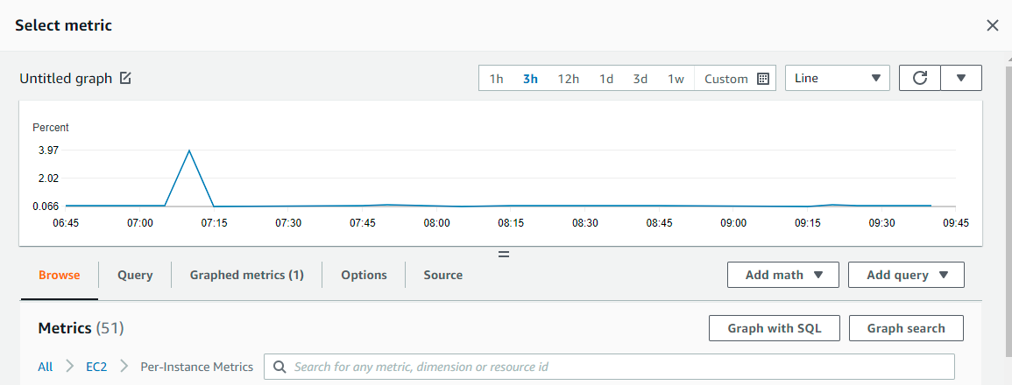

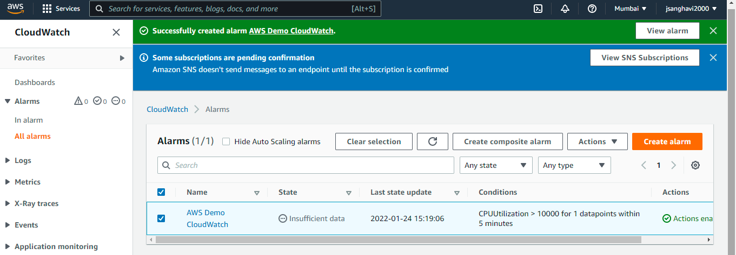

1. **Cloudtrail:** AWS **CloudTrail** is an AWS service that helps you enable governance, compliance, and operational and risk auditing of your AWS account. Actions taken by a user, role, or an AWS service are recorded as events in CloudTrail. Events include actions taken in the AWS Management Console, AWS Command Line Interface, and AWS SDKs and APIs.

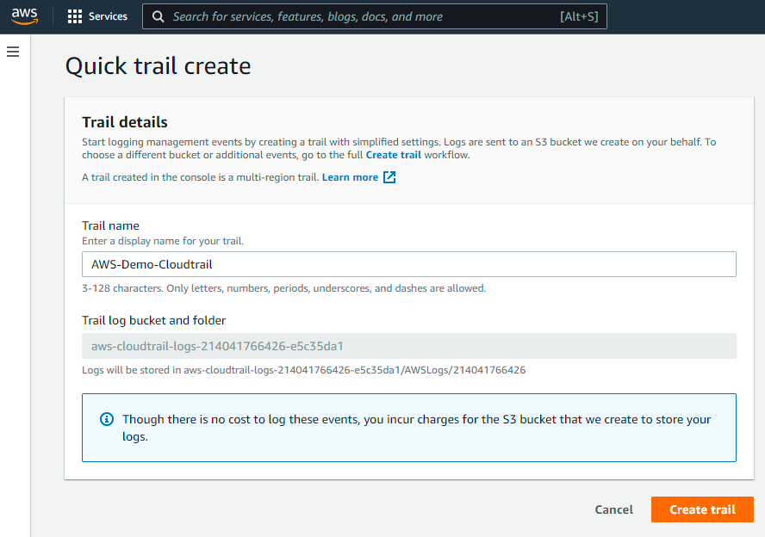

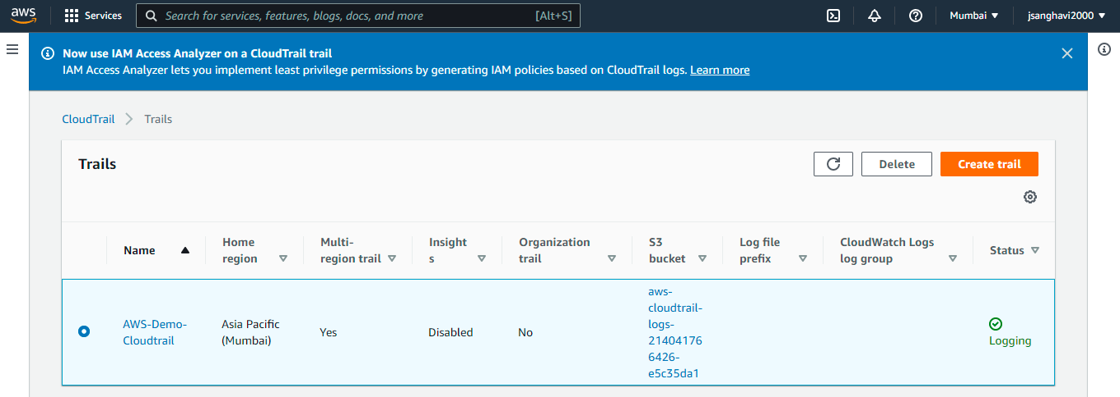

1. **Route53:** It is a highly available and scalable DNS (Domain Name Service) service. It provides a reliable and cost-effective way for the developers and businesses to route end users to internet applications by translating domain names into numeric IP addresses.

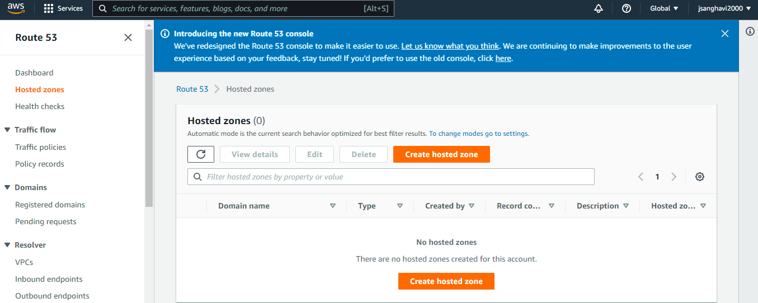

**4) Learn below GCP Services.**

1. **Compute Engine:**

* Google Compute Engine (GCE) is an Infrastructure as a Service (IaaS) offering that allows clients to run workloads on Google's physical hardware.
* Google Compute Engine provides a scalable number of virtual machines (VMs) to serve as large compute clusters for that purpose. GCE can be managed through a RESTful API, command line interface (CLI) or Web console. GCE competes with Amazon's Elastic Compute Cloud (EC2) and Microsoft Azure.
* GCE's application program interface (API) provides administrators with virtual machine, DNS server and load balancing capabilities. VMs are available in a number of CPU and RAM configurations and Linux distributions, including Debian and CentOS. Customers may use their own system images for custom virtual machines. Data at rest is encrypted using the AEC-128-CBC algorithm.
* GCE allows administrators to select the region and zone where certain data resources will be stored and used. Currently, GCE has three regions: the United States, Europe and Asia. Each region has two availability zones and each zone supports either Ivy Bridge or Sandy Bridge processors. GCE also offers a suite of tools for administrators to create advanced networks on the regional level.

1. **Cloud Storage:**

GCP has following Storage Services:

1. **Google Cloud Storage:** It is an online data storage web service that Google provides to its users to store and access data from anywhere. The service also includes a wide range of features like maximum performance, scalability, security and sharing.
2. **Cloud SQL:** It is a web-service that enables users to create, manage, and use relational databases stored on Google Cloud servers. The service itself maintains and protects the databases, which helps users focus on their applications and other operations.
3. **Cloud Bigtable:** It is known for its fast performance and highly manageable feature. It is a highly scalable NoSQL database service that allows collecting and retaining data from as low as 1 TB to hundreds of PB.
4. **Local SSD:**

* **Local SSDs** are physically attached to the server that hosts the VM instance.
* Local SSDs have higher throughput and lower latency than standard persistent disks or SSD persistent disks.
* The data that you store on a local SSD persists only until the instance is stopped or deleted.
* Local SSDs are designed to offer very high IOPS and low latency.
* Compute Engine automatically encrypts your data when it is written to local SSD storage space. You can’t use customer-supplied encryption keys with local SSDs.
* Each local SSD is 375 GB in size, but a maximum of 24 local SSD partitions can be attached for a total of 9 TB per instance.

1. **VPC:**

* A **Google Virtual Private Cloud network** is very similar to a physical network, except that it is virtualized within the Google Cloud Platform (GCP).
* A VPC network is a global resource which consists of a list of regional virtual subnetworks (subnets) in data centers, all connected by a global wide area network. VPC networks are logically isolated from each other in the Google Cloud Platform.